**CHAPTER 1**

**INTRODUCTION**

**1.1 Bank Card**

In recent times, people are more often to bring along their bank cards such as credit card or debit card whenever they go for shopping, paying bills and etc. as it much more convenient as compared to the traditional method which is having a stack of money in the pocket. In Malaysia, having a bank card has become a norm among the Malaysian but this norm is slowly decreasing due to the upcoming alternative payment method such as Bitcoin, Mol Point and etc. Statistics shows that the number of credit cards holder in Malaysia has fallen from 8.21 million (2011) to 8.07 million (2012) (Bank Negara Malaysia, 2012).

* + 1. **Customized Bank Card**

Today, most of the bank cards that we are holding right now has the same outlook which is quite common and it does not show any uniqueness as compared to other card holders. Old school looked of bank card is no longer attractive anymore as human are always seeking for something that are new and attractive. With a customizable bank card, card holders are able to print their favorite photos such as family’s photo, sweet couple’s photo on the card and at the same time it also increases the aesthetic value of the card which make it much more unique as compared to the normal bank card. On the other hand, bank corporate are able to increase their revenue by providing services which allowed their customers to customize their own bank card.

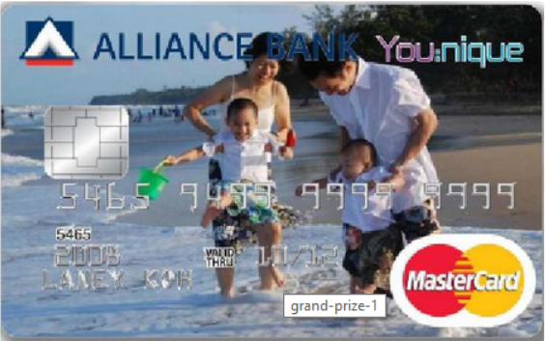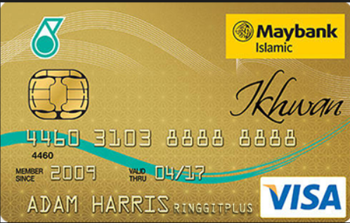

**Figure 1.1.1: Customizable bank card and Non-customizable bank card**

* 1. **Problem Statement**

DataSonic which is a company that provide card printing services to most of the government agencies and private sectors in Malaysia. This company wanted to use some kind of image processing technique and software to process the image captured by the cardholders and eventually printed it on the customer’s bank card. The purpose of providing this services is to help the bank customers to differentiate their cards from the others as the cards that we have it right now are quite similar and somehow it looks dull in term of its design.

By providing this services, customers are able to personalize or customize their bank cards based on their desired pictures or photos. However, there are a few main issues that need to be rectified: Firstly, based on the company’s requirement, they wished to have a kiosk which allowed the customers to take their photos at the kiosk and immediately printed it on the card. But, this is not an ideal way as it will hassle the customers since the customers would need to queue up for a long time and having a few minutes to customize their photo.

Next, user friendliness of the system is one of our major concern in which our system must make sure that every single user either novice user or expert user are able to use this system easily. Other than that, the platform to deploy this application will also be put into consideration. Building a Window application that operate at a single kiosk would no longer be sufficient and efficient to handle the high demand of customers towards this services.

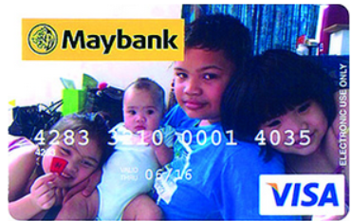

**Figure 1.1: Personalized Maybank debit card without image processing technique.**

**1.3 Project Objective**

**1.3.1 General Objective**

This project is intent to provide an image processing application with multi touch functionality which can run on a kiosk system that are able to deal with the high customers demand and help the customers in customizing their card more effectively and efficiently with just a few clicks using this application.

**1.3.2 Specific Objective**

1. To develop a Windows application with the capability of image processing functionality in order to enhance the photo or pictures captured by the customers.

2. To allow customers to choose different kind background, frame (love shape, star shape, square, and etc.) and effects that they wish to add onto their photos.

3. To help the bank in generating extra revenue as this project may glad the card holders to apply or replace a new card.

4. To provide a kiosk that allow the customer to take their photo at the kiosk and instantly printed the photo on the card within 15 minutes.

5. To allow the customers to upload their photo by using USB onto the software and perform different kinds of image processing functionality onto the image.

* 1. **Project Scope**

This project aim to deliver a kind of image processing application that helps the bank customers in customizing and personalizing the bank card. The development comprises of these modules:

* **Windows Type of Image Processing Application** 
  + This application will be running on the Windows platform because Windows is the most popular operating system that used by the public as compared to the others like Mac and Linux.
* **C# Program**
  + This application will be programmed using C# language and the IDE to program this application will be Visual Studio. Library file such as AForge, OpenCV will be used to develop the interface of this application.
* **Uploading Capability**
  + End user of this application will be able to upload their photo or pictures through this application before they perform any kind of image processing functionality.
* **List Of Image Processing Toolbox, Background and Frame**
  + A list of image processing toolbox and frame will be included in the application so that the users can choose different kinds of effect and frame that they wished to add on to their pictures or photos.
* **Temporary Local Server**
  + A temporary server will be hosted on the local machine using Phpmyadmin or Xampp that act as a storage to store all of the images that have been processed by the application.
* **Integration With The Printer**
  + This application is capable of sending the output of the processed image to the printer located at the kiosk and printed it on the bank card.
  1. **Possible Limitation**

**The possible limitations that might be faced by the apps are:**

* The apps won’t be able to detect the vulgar gestures and naked photos that captured by the customers.

**1.5 Technology Used**

* Development Tools
  1. Visual Studio
  2. PhpMyAdmin
  3. OpenCV
  4. AForge
  5. Version Control Software (GitHub, Google Drive)
  6. Continuous Integration Tools (Jenkins)
  7. EmguCV
  8. Kiosk provided by DataSonic
* Programming Language Used
  1. C#
  2. MySQL
  3. Git Command

**CHAPTER 2**

**LITERATURE REVIEW**

**2.1 Interactive Kiosk**

An interactive kiosk is some kind of computer devices that deployed at the public venue which allowed people to access to any services or products via it. Basically, a kiosk functioned like a normal pc and it allowed the users to access internet via it. The only difference between a kiosk and a typical PC is that, a kiosk only performs some specific task and is often designed to be used by different people. (WireSpring)

Kiosk is normally equipped with touch screen capability which allowed the users to use it without any hassle or facing any difficulty. It is normally used in places which deal with a lot of customers such as airport. By installing an automated check in system at the airport, it helps to make the check in process faster and more efficient as compared to manual check in.

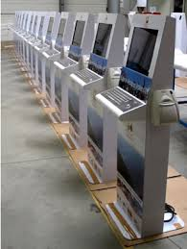

**Figure 2.1: Interactive Kiosk**

**2.2 Kiosk Software**

In the past, a kiosk software is usually layered on top of a general purpose operating system. But today, a list of kiosk functions has been integrated directly into the core system software by a new purpose built kiosk operating system.

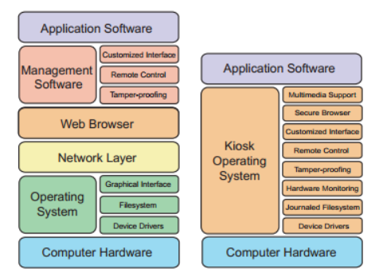

**Figure 2.2 Architecture of kiosk software**

An interactive kiosk comprises of three main software which are:

1. Operating System Software
2. Application Software
3. Kiosk Management Software

**2.2.1 Operating System Software**

Similar to desktop PC, an interactive kiosk required an operating system in order for it to run its application. Operating system act as a basic set of tools in identifying the computer hardware and allowed the computer to run its application. Those operating system are often preinstalled in the computer when users purchased it. But, there are also some of the open source operating system which allowed the users to download it freely from their website such as Linux.

Although, there are many kinds of operating system available in the market, but still Windows is the most popular operating system that is installed in an interactive kiosk as compared to the others. This is because Windows do offer a wide range of operating system that is specifically designed and used in the embedded devices such as interactive kiosk.

In recent years, several companies has come out with operating system that is designed solely to run interactive kiosk such as Firecast OS which is built by WireSpring is a pure interactive kiosk’s operating system and this operating system has its owns management software to manipulate those integrated features such as multimedia support, tamper-proofing and etc. Unlike the past, in which kiosk owner would just simply run an operating system like Microsoft Windows and use a 3rd party software to add in any kiosk specific features and cover up any holes.

**2.2.2 Application Software**

There are a variety of kiosk software application and is often custom-built to meet certain purpose. For example, an atm machine is built to help the bank to service its customer better without having their customer to wait or queue for a long time. Some of the kiosk application might as well modified from the existing application in order to make it acceptable by public use. On the other hand, some of the sophisticated kiosk application are written from scratch and are purposely designed to handle the challenges of public environment such as an atm machine, airport check in system and etc.

**2.2.3 Kiosk Management Software**

Kiosk management software is used in kiosk to allow the kiosk project manager to manage the kiosk efficiently and to lower down their maintenance cost. This software is responsible for three type of tasks which are:

1. **Security Tasks**

One of the major purpose of kiosk management software is to protect the kiosk from any intentional or unintentional attack such as cracking, unauthorized access, hacking and etc. All these attack will not only cause a kiosk down but on the other hand it may expose some sensitive corporate data to those hackers.

1. **Application Tasks**

This software packages also allowed the kiosk administrator to customize the user interface of a particular kiosk such as add on addition help messages, using attractive buttons, icon and etc. in order to attract the user’s attention towards the kiosk.

1. **Management Tasks**

The kiosk management software also allowed those management and maintenance stuff to be done remotely without having the technician to fix the machine on the spot in which it is quite troublesome and time-consuming. This also allows the kiosk owners apply any security patches and latest content to their kiosk without having to make any service call.

**2.3 Operating System**

Although there are a few operating system that are typically built for kiosk software available right now, but due to several factors, this application would not be built upon those operating system such as FireCast OS. This is because:

1. Those operating system are quite newly introduced and it might not be easier to use and it is hardly to seek for help if there’s any problem occur.
2. Higher cost.
3. Less documentation.

Besides that, instead of building this application using the pure kiosk’s operating system, developers can still build their application on top those operating system that we are familiarize with such as Windows, Mac OS and Linux. And the table below shows a comparison in between this three operating system:

|  |  |  |  |  |
| --- | --- | --- | --- | --- |
| OS Name | OS Developer | Latest Version | License | Status |
| Windows | Microsoft | Windows 8.1 | Proprietary | Active |
| Mac OS | Apple | Mac OS X Mavericks (10.9.4) | Proprietary | Active |
| Linux | Linux Foundation/ Community | Version depends of different type of Linux such as Ubuntu, Fedora and etc. | Open Source | Active |

**Table 2.1: Major Operating System in the World**

According to NetMarketShare, which is one of the popular web traffic analyzing tools has come out with a statistics that shows that the world operating system is currently dominated by Windows (Windows 7, XP, 8, 8.1) which made up a total of 91.35% out of the market share and the number of Windows users are far more compared to Mac OS and Linux.

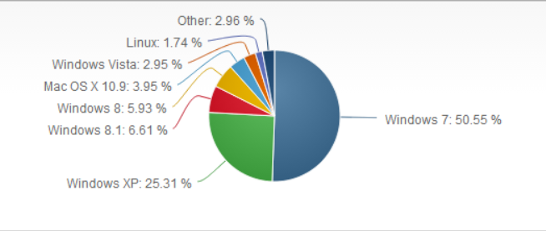

**Figure 2.3: Operating System Market Share On June 2014 (NetMarketShare)**

In a conclusion,Windows platform would be more favor as the hardware cost of it is much cheaper as compared to Mac OS. (Dachis, 2013) Besides that, Windows is the most popular operating system with more than 90% of the computer users running or using Windows products so this is the best justification on why this application should be developed on Windows.

**2.4 Development Platform**

It is essential for developers to determine on which platform they are going to build their application on and it often came into a situation whereby developers are having a hard time in choosing their development platform. Currently, there are a variety of platform available for developers to develop a rich-based user interface application but in this project, only the two most popular platforms which are Java and .NET will be taken into consideration.

Besides that, selection of development platform between Java and .NET is very subjective and also depends on a few constraints and requirements:

* Application Complexity
  + Since this application is going to deploy as a kiosk software, therefore a rich user interface with appropriate GUI components is necessary for this application. Unlike Java which only provide some basic swing GUI components, .NET offers a better environment with richer user interface components in order for developers to design a rich user interface application and this environment we normally known it as Windows Form.
* Developers’ Skillset
  + Since both of these platform offered some kind of object-oriented programming language such as Java and C Sharp, therefore it shouldn’t be a problem for developers to choose either one platform.
* Company’s Preferences
  + Company’s preferences are often the main priority in deciding which platform to use as this might affect the future refinement and maintenance of this application and for this case, the company prefers the developers to develop the application on .NET platform as compared to Java platform.
* Application Portability
  + Since this application is not going to deploy at any other operating system besides Windows, therefore .NET platform would be a better option as compared to Java.
* Cost of Solution
  + There is often some trade off in between the quality of a software and cost of solution. If developers would like to have a software with better features therefore they would have to pay for it just like Visual Studio in .NET platform and in some cases, the cost of solution is often handled by the company.
* Outside Vendor Support
  + Both platform allowed their developers to import all the required libraries that are developed by the third-party vendors.

Apart from the above, list of comparison in between Java and .NET has been carried out and are drawn in the table below

|  |  |  |
| --- | --- | --- |
|  | Java | .NET |
| Language | **Java, Groovy, JavaScript and others.** | **C#, VB.NET, C++ and others** |
| Developer | **Sun Microsystems** | **Microsoft** |
| Operating System | **Multiple or Cross-Platform** | **Windows** |
| Client/GUI Components | **JavaBeans** | **.NET class** |
| License | **Open Source** | **Proprietary** |
| Runtime | **Java Virtual Machine (JVM)** | **Common Language Runtime (CLR)** |
| IDE Support | **Netbeans, JCreator, Eclipse and etc.** | **Visual Studio** |
| Unit Testing | **Microsoft Unit Testing Framework, NUnit** | **JUnit** |

**Table 2.2: Comparison between Java and .NET platform**

After evaluating both .NET and Java platform, .NET platform is still preferred for the development of this project as compared to Java platform. This is mainly due to its rich GUI components as compared to some basic swing GUI components provided by Java platform. Besides that, portability of this application is not a major concern, therefore it would be better for developers to develop this application on top of Windows platform which are more popular compared to the others such as Linux and Mac OS.

**2.6 Image and Digital Image**

Every image that we see can be defined as a two-dimensional function, f(x,y), where x and y are plane coordinates, and the intensity or gray level of the image are refer to as the amplitude of function f at any pair of coordinates (x,y). An image is normally known as a digital image if the coordinate x, coordinate y and the intensity values of function f are all finite (C.Gonzalez and E.Woods, 2010). Pixel is normally used to denote the finite number of elements of digital image and each of the pixel has a particular location and value.

**2.6.1 Image Processing and Digital Image Processing**

Image processing has become something that is quite common nowadays due to the evolution of computer technology and the fact that nearly everyone has some type of device for digital image acquisition such as a scanner, smartphone camera, camera and so on and this lead to the plethora of digital image. Unlike the past where manipulation of a digital image can be only done by a small group of specialist who had access to expensive equipment and usually this can be only found in the research labs (Burger and J.Burge, 2008).

The technology of using a series of computer algorithm to process the digital images are known as Digital image processing. The outcomes of this process can be either images or a set of representative characteristics or properties of the original images. (Huiyu, Jiahua and Jianguo, 2010).  There are many digital image processing software out there which allowed the user to further process or enhance their images or photos using a list of features provided by the software such as contrast, brightening, cropping, and etc.  Other than that, image processing also helps human beings in obtaining high quality images or descriptive characteristics of the original image (Huiyu, Jiahua and Jianguo, 2010).

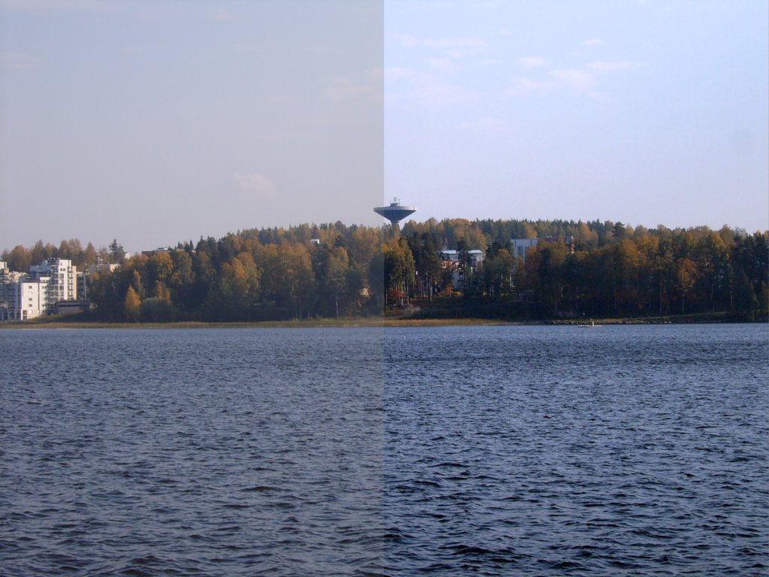

**Figure 2.4: An example image that applied contrasting feature**

**2.7 Implementation Technique - Masking**

Technique such as masking would be used in this project in order to combine or merge few images together to produce a fresh new image. The term masking in image processing refers to the technique used to obscure certain parts of an image and allow other parts of it to be displayed or show. This technique can be achieved by performing logical operation on the relative pixel of an image. Since logical operation can only be used to calculate the bit value which is either one or zero, therefore by performing the operation on two different images will often result in a different output except for NOT operation which only deal with a single image. Pixels that deal with RGB can also perform the logical operation but it requires the operation to convert 8 bit binary digit instead of a single digit.

**2.7.1 Bitwise Logical Operation**

List of logical operation that are often used in image processing are:

* AND
* OR
* NOT
* SUB
* XOR

All of these operations will be illustrated using two of the images as shown below where the binary value “0” representing the black and “1” representing white:

 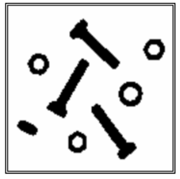

1. **Image *a* (b) Image *b***

**2.7.1.1 AND Operation**

AND operation usually takes one binary value from each of the two gray scale images as an input in order to produce a third image whose pixel values are typically same as the first image. The output of the corresponding AND operation is shown in Figure 2.5.



**c) AND(a,b) = a*b**

**Figure 2.5: Example of image produced by AND operation**

The above operation can be explained using the truth table as shown below:

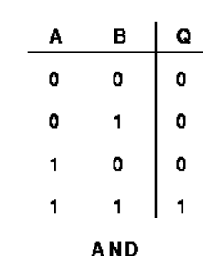

**Figure 2.6: Example of truth table for AND operation**

**2.7.1.2 OR Operation**

Or operation or more commonly known as Union operation is typically used to merge two images. After performing an OR operation on both image a and b the output of it is shown in Figure 2.7.

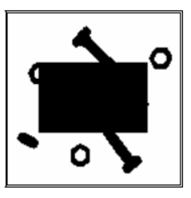

**d) OR(a,b)=a+b**

**Figure 2.7: Example of image produced by OR operation**

The above operation can be explained using the truth table as shown below:

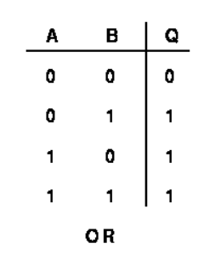

**Figure 2.8: Example of truth table for OR operation**

**2.7.1.3 NOT Operation**

NOT operation is often known as negation or inversion. It is commonly used to convert a particular argument to another argument such as bit “0” to bit “1” in image processing. Figure 2.9 shows an example of image that are produced after performing NOT operation on image b.

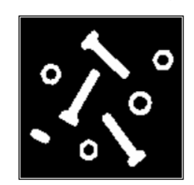

**e) NOT(b)= -b**

**Figure 2.9: Example of image produced by NOT operation**

**2.7.1.4 SUB Operation**

SUB operation works pretty the same as XOR operation, but SUB operation intended to discard or remove the subtracted region from the image and Figure 2.10 shows an example of image that is produced after sub operation has been applied to both image a and image b.



**f) SUB(a,b)= a \ b**

**Figure 2.10: Example of image produced by SUB operation**

**2.7.1.5 XOR Operation**

XOR operation intends to return a positive value if just one of the value is true and the other one is false. For example, if both images with a particular pixel values of “1” which is black will result in an output with pixel value of “0” which is white if both images perform a XOR operation. Figure 2.11 illustrates the output of image produced by XOR operation.

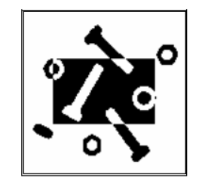

**g) XOR(a,b)= a $xor$ b**

**Figure 2.11: Example of image produced by XOR operation**

The above operation can be explained using the truth table as shown below:

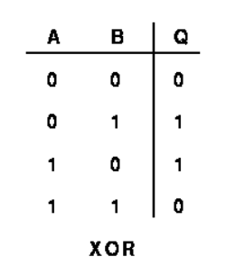

**Figure 2.12: Example of truth table for OR operation**

**2.7 Existing Application in The Market**

Currently there are a lot of software applications with image processing functionality available in the market. For example: Google Picasa, Instagram, Adobe Photoshop, GIMP and etc. Some of these applications will be studied, analyzed and compared based on the functions that will be delivered under the current project scope.

Besides that, there also exist some web application which allowed the users to customized their bank card using that application such as Alliance Bank’s You:nique card services. Such application will be fully analyzed to act as a benchmark for this project.

**2.7.1 Alliance Bank’s You:nique Card Service**

You:nique card services is a program that launched by Alliance bank in year 2009, this program allowed the public to apply their bank card via online application. Besides that, it also allowed the public to customize their bank card via an online web application. The figure below shows the main screen of this application.

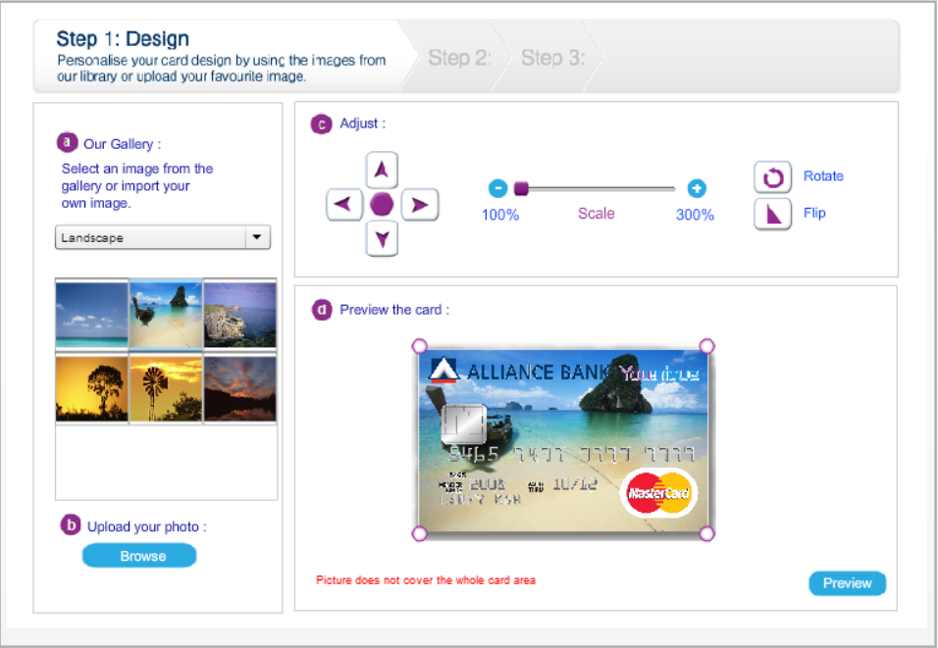

**Figure 2.5: Screenshot of You:nique’s web application**

The application provides the following features:

* Gallery
  + This application provides an image gallery for users to select the image from this gallery.
* Photo Uploading Capability
  + This application allows the users to upload their favorite photos onto the web application.
* Photo Adjustment
  + This application does provide a photo adjustment features for users to adjust their photo to the according card template.
* Image Scaling
  + This application provides an image scaling features for users to scale their image.
* Image Rotation
  + User can rotate their photo to the respective coordinate provided by this application.
* Image Flipping
  + This applications allowed the image to be flipped through y-axis

Although the user interface of this web application looks simple and easy to use, but a few more features such as image gradient, blurring and cropping can be added to this application for users to have a better option in customizing their card. Besides that, this application is not user friendly enough in which it does not allow the subscribers to actually scale the image horizontally in which it is not so convenient.

**2.7.2 Google Picasa**

Google Picasa is one of the most popular image processing software applications that is mainly meant for organizing image and editing digital photos. Since it is a freeware, users can download and install it on their computer and then they can start to enjoy different kinds of image processing features in this software. Picasa is also integrated with an image sharing capability so that users can upload their image or photos after processing it. Figure 2.5 shows the screenshot of Google Picasa and certain image processing features in this software.

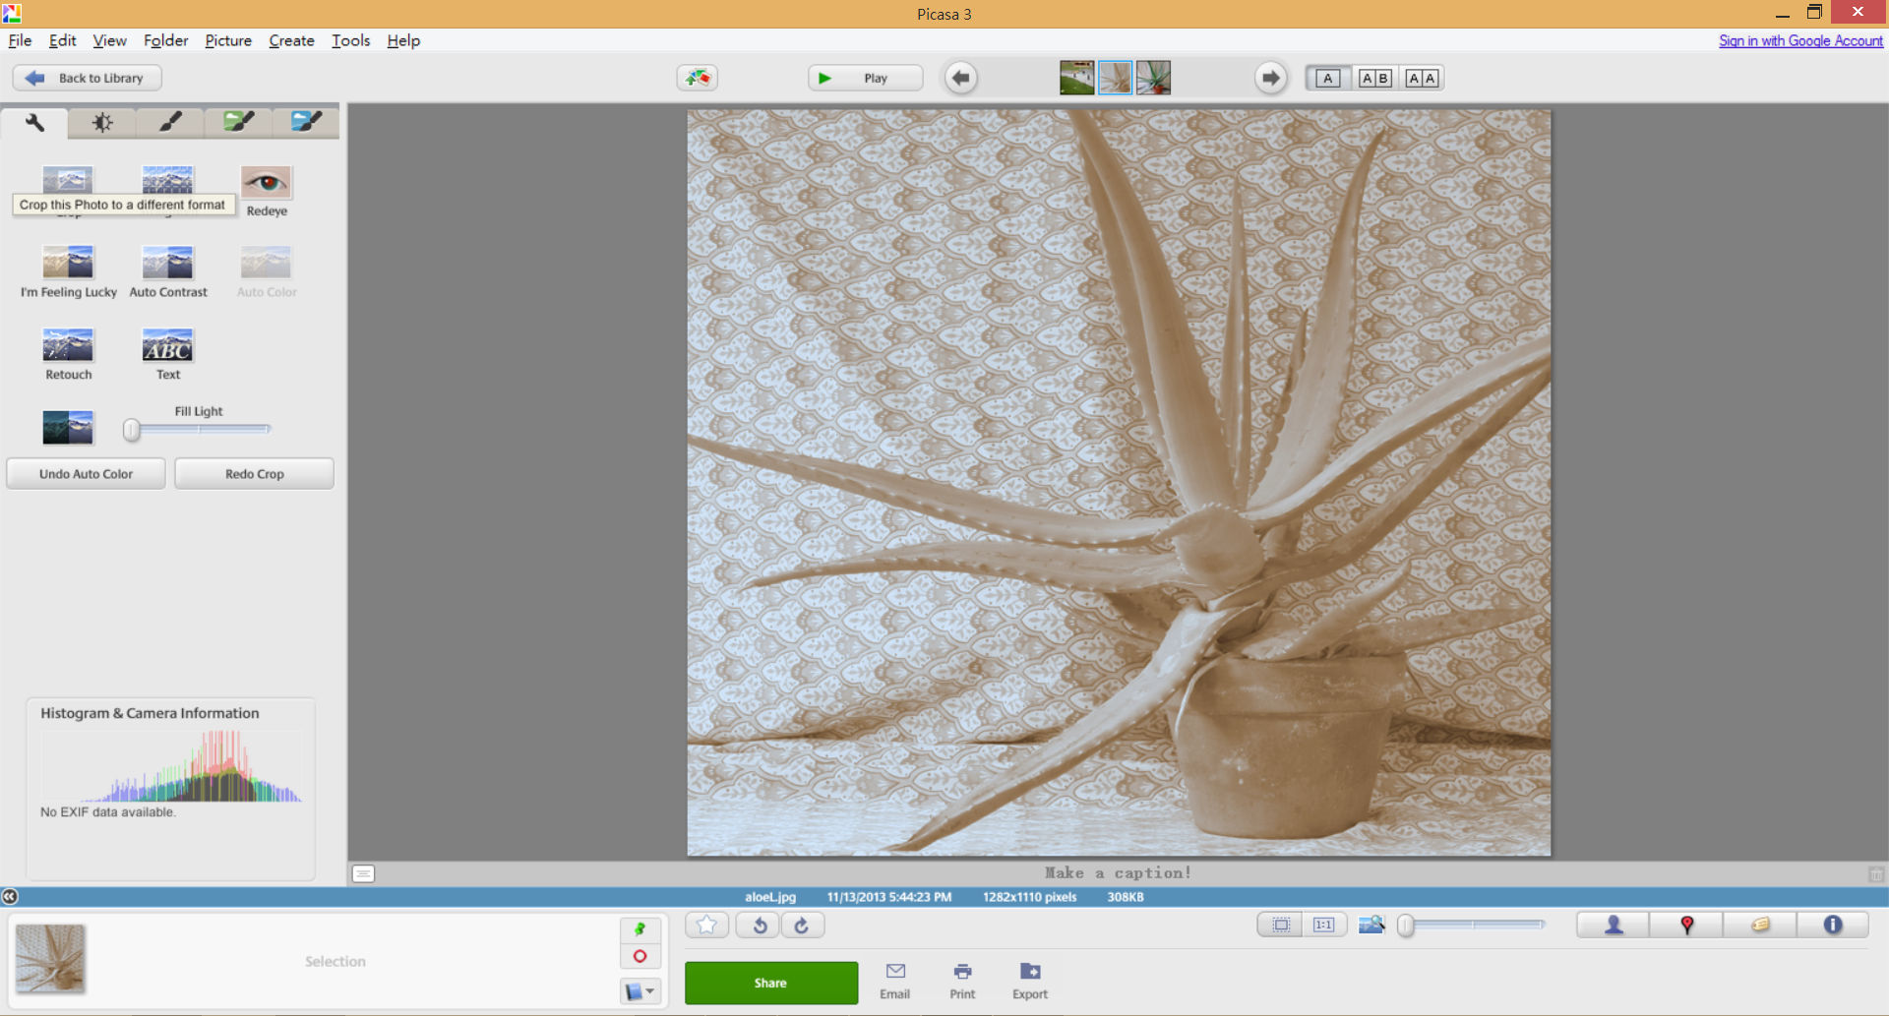

**Figure 2.6: Screenshot of Google Picasa**

Since Google Picasa does provide a variety of image processing features, but only a few of it will be studied and act as a benchmark for this project. Those main features that will be studied are as followed:

* Cropping
  + This application allows the users to crop their image.
* Red Eye Repairing
  + Red eye are able to detect by this application and it is able to repair those red eye that has been detected.
* Adding Text
  + This application provides text adding features on an image.
* Auto Contrast
  + This application does provide auto contrast features on the image.
* Image Gradient
* This application provides list of image gradient option for user to change the intensity or color of an image.

Although Google Picasa is well known for its image processing capability but the user interface of it is not well designed as a novice user or the first time user might have difficulty in navigating all the features available in this software due to the functions that provided by it is quite vague and hardly to understand. For example, user might not know what is function of I’m feeling lucky without actually pressing the button of this feature.

**2.7.3 Instagram**

Instagram is a well-known mobile social application with image processing functionality that integrate on it which enable the user to process the image with just a few click before sharing it onto social media sites such as Facebook. The image processing features provided by Instagram is just suffice for this mobile application. Besides that, the user interface of Instagram is pretty good and user can easily navigate on those image processing features as compared to other tool which is too complex just like Adobe Photoshop. Figure 2.6 shows the screenshot of Instagram with its image processing features.

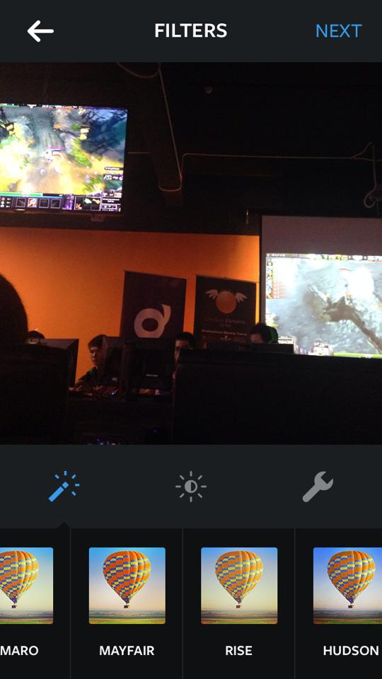

**Figure 2.7: Screenshot of Instagram**

Those main image processing features provided by Instagram are as followed:

* Image Gradient
  + This application provides list of image gradient option for user to change the intensity or color of an image.
* Lux
  + By performing this feature, users are able to make their photo more vibrant.
* Adjust
  + Instagram provides the image adjusting features which integrate both image cropping and straightening together.
* Brightness
  + This application does provide an option for users to adjust their desired brightness on a respective image or photo.
* Contrast
  + This application does provide auto contrast features on the image.
* Tilt Shift
  + Tilt shift provided by Instagram works just like image blurring.

**2.7.4 GIMP (GNU Image Manipulation Program)**

GIMP is a raster graphics editor which is used for image retouching and editing, resizing, free-form drawing, cropping, converting between different image formats and other more specialized tasks. Basically, GIMP can be consider as a pure image processing software application whereby this program has a lot of image processing features and functionality unlike Instagram which only allowed the user to experience some basic image processing features in its application. Figure 2.7 shows an example of image open at GIMP and using its image scaler functionality to scale the image.

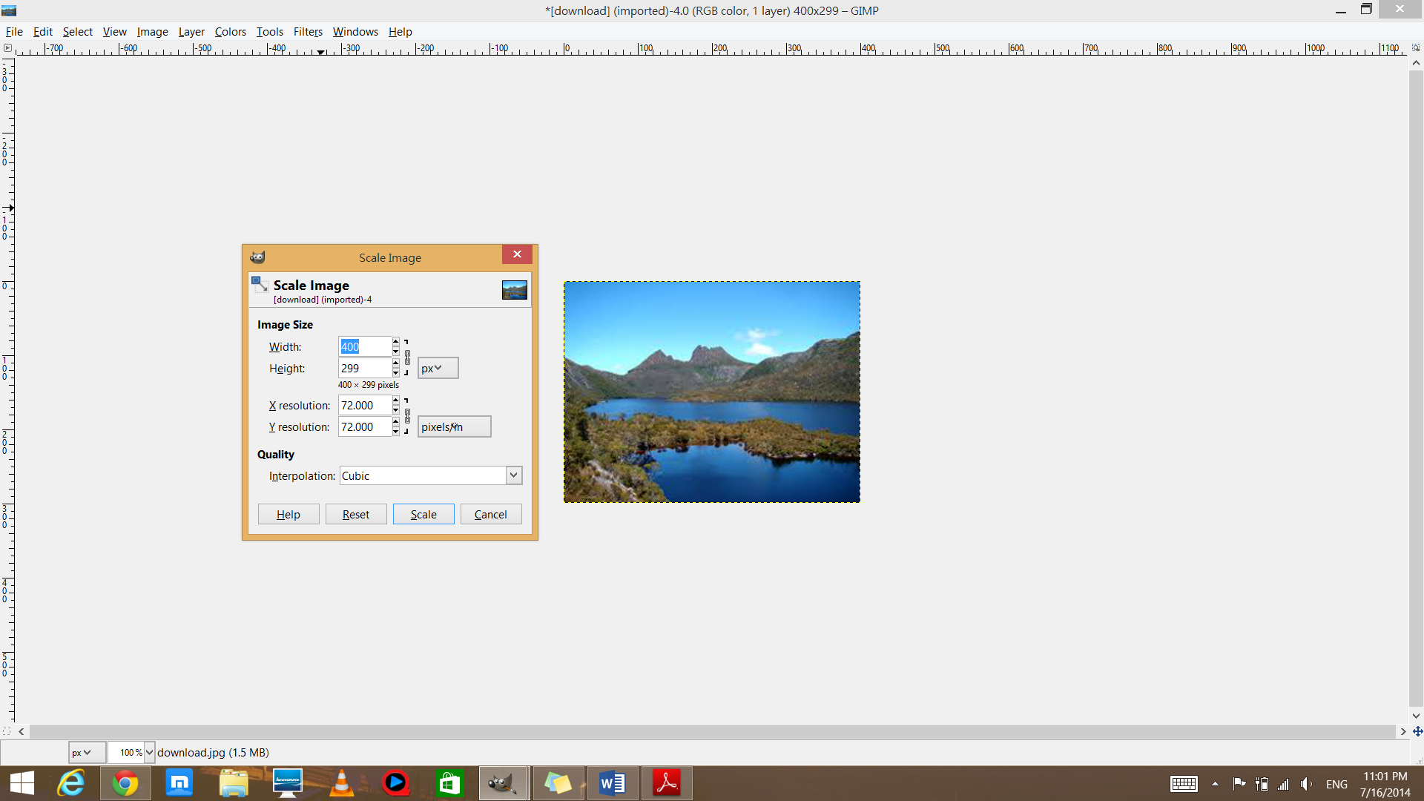

**Figure 2.8: Screenshot of GIMP**

Those main features provided by GIMP that will be studied are as followed:

* Brightness-Contrast
  + The application provides an option for the users to adjust the brightness of an image.
* Layer
  + List of layer features are provided in this application such as masking, transform, stack, transparency and etc.
* Blurring
  + Set of blurring features are provided in this application such as Gaussian blur, Motion blur, Tileable blur and etc.
* Invert
  + This application does provide a color invert features for an image.
* Image Scaling
  + This application provides an image scaling features for users to scale their image.
* Adding Text
  + This application allows the users to add some text on the image they wish to process.
* Many More Image Processing Features
  + Since it is a pure image processing software, there are a lot more image processing features which are not necessary for this project as it might confuse the users.

The user interface of GIMP is bad and not user friendly in which users have to navigate between the menu bar in order to search for those features that they wish to apply on a particular image. Besides that, the term used by this program is too jargon in the sense that it might not be easily understood by those novice users and one of the flaw is that the users would need to manually input those value such as coordinate or pixel value if the wish to perform scaling and rotating on a particular image and this might cause the users to perform a few tries before they could get the actual result that they want and this also violate “Shneiderman’s Eight Golden Rules of Interface Design” which states that a good user interface should able to reduce the short term memory load of the users in which users won’t have to memorize all the coordinates value in order to get the desired output.

**2.8 Shneiderman's "Eight Golden Rules of Interface Design"**

In order to improve the usability of an application and reduce the amount of time spent by the users, it is essential to have a good designed interface. The “Eight Golden Rules of Interface Design” which proposed by Ben Shneiderman are a guide to good user interface design.

**2.8.1 Strive for consistency**

Strive for consistency simply means doing the same thing using the same way every time in other word it means that the consistent sequences of actions should be applied in similar situations and it shouldn’t go against the human perception. For Example: in a simple user interface, green color should represent start and red color should represent stop, but if this design go the other way round, it will cause inconsistency to the interface design. Figure 2.9 and 2.10 shows an example of consistent and inconsistent interface design.

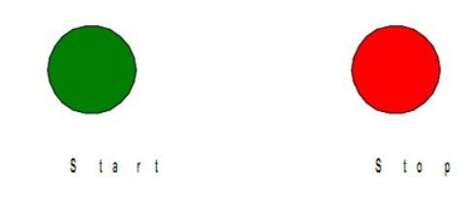

**Figure 2.9: Consistent interface design**

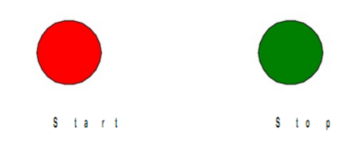

**Figure 2.10: Inconsistent interface design**

**2.8.2 Enable frequent users to use shortcut**

In order to increase the pace of interaction, it is important that a series of shortcuts such as abbreviation, hidden commands, and function keys should be implemented in a particular user interface. For example: users can simply press CTRL + P in order to print the photo instead of clicking the “Print” button. An example of program with shortcut key implement is shown in Figure 2.11.

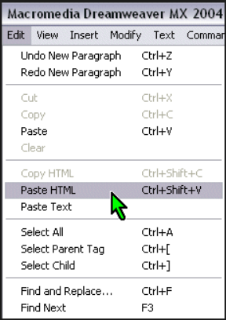

**Figure 2.11: Screenshot of program with shortcut key**

**2.8.3 Offer informative feedback**

Informative feedback is very important in the sense that it let user know that certain operation is currently in progress. For example, most of the applications are implemented with the loading bar in order to notify the user that certain operation is in progress. An example of informative feedback such as a loading icon is shown in Figure 2.12.



**Figure 2.12: Screenshot of loading icon**

**2.8.4 Design dialog to yield closure**

Dialog box is rather important in order to warn the user if there is any error, to get user input in order to make certain decision and etc. For example, most of the application like Microsoft Word will prompt a dialog box to ask whether the user would like to save a particular changes on a document when they exit from it. Figure 2.13 illustrate an example of dialog box.

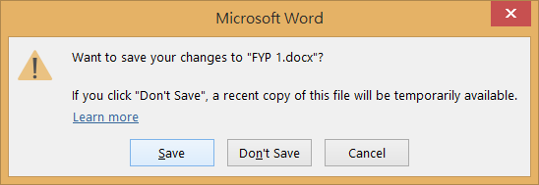

**Figure 2.13: Screenshot of dialog box**

**2.8.5 Offer simple error handling**

A system should be design in the sense that no any serious error can be made by the user. If an error is made, the system should be able to detect it and offer some comprehensible and yet simple mechanisms for handling the error. Figure 2.14 shows an example of program with simple error handling implemented.

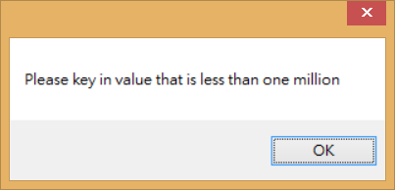

**Figure 2.14: Screenshot of simple error handling**

**2.8.6 Permit easy reversal of actions**

Permit easy reversal of actions would allow the user to explore any unfamiliar options in the system since the user knew that error can undone. For example, by providing a back button will allow the user to return to its previous session without causing any error to the system. Figure 2.15 illustrate an example of web application that permit easy reversal of actions.

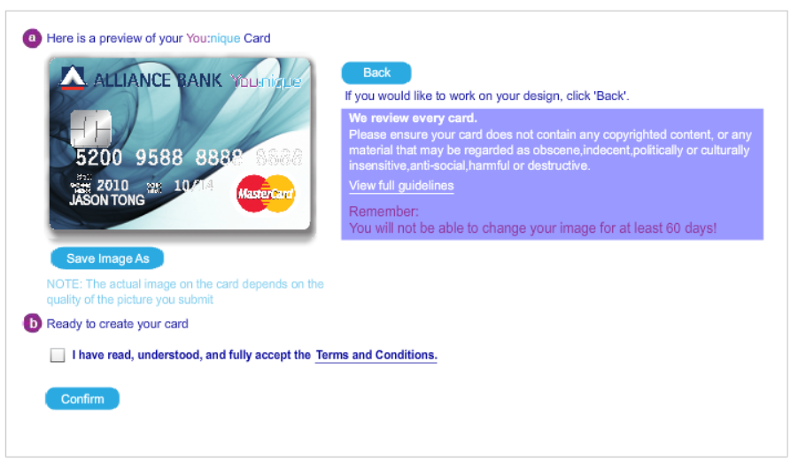

**Figure 2.15: Web application that allow easy reversal of action**

**2.8.7 Support internal locus of control**

Experienced operator are often granted permission to take care of the system and respond to any actions that make towards the system. For example, certain operation like updating database can only be done by administrator with permission granted to him. Any other user won’t have the authority to do so.

**2.8.8** **Reduce short-term memory load**

A good user interface is often designed in the sense that it is simple and won’t have too many page as this will help the user in reducing their short term memory load. Shortcuts should be implemented in order to achieve this goal. For example, radio group are often used to group a particular radio button with similar characteristic.

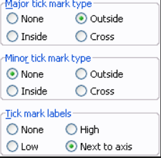

**Figure 2.16: Screenshot of radio group and radio button**

**2.9 Touch Screen Capability**

In order to increase the human-computer interaction and to reduce the demands of user towards computer, touch screen applications has been designed to reduce the motor effort of users to use the interface. Besides that, due the evolution of IT technology especially in mobile field has further encourage the development of touch screen application across different platform such as mobile, computer, kiosk and etc.

In this project, kiosk application with touch screen capability will be developed in order to handle high demand of customers towards this services and further reduce the time spent by each customer when they are customizing their card using this application.

**2.9.1 Benefit of Touch Screen Application**

Touch screen application is slowly replacing human beings and computers in many aspect of life. For example, many restaurants started to implement the touch screen system which are able to make their ordering task faster and hence simplify their task. Below shows a list of essential benefits provided by touch screen application which are related to this project (Joseph, n.d.):

* Ease of Use
  + Touch screen application is easy to use and are able to remove the apprehension of people who are uncomfortable with computers. People can get their things done more easily by just swiping over the screen.
* Self-Service
  + With the implementation of touch screen application, it helps certain big corporate like bank corporate to serve their customers more efficiently and avoid their customers to queue for a long time by setting up a self-service machine at their bank such as ATM machine.

**2.10 Image Processing Features**

There are a lot of image processing features available out there, such as blurring, auto contrast, red eye detection, scaling, rotation, image gradient and etc. But in this project only certain popular features will be focused so that it won’t confused the users and also help to minimize the service time in kiosk.

**2.10.1 Blurring**

The concept of blurring is just similar to a situation in which the camera is not in focus. The reason of this is because the sharp point of an image that we see gets smeared out and usually into a disc shape. In image processing term, it means that each pixel of an image gets spread over and usually mixed with the surrounding pixels and this operation we normally known as convolution. (Jerry, n.d.) Blurring can be done with some mathematical operations and this can be explained using the following steps:

1st step: Firstly, a convolution kernel that make up of a rectangular array of numbers is being slide over the image. An example of convolution kernel is as followed:

1/9 1/9 1/9

1/9 1/9 1/9

1/9 1/9 1/9 *An array with size nine*

If we add up all the numbers in a kernel, the result that we got is one and this representing the original image.

2nd step: In order to create a blurred image, we would need to multiply the kernel value with the corresponding pixel value together and sum them up to produce a new pixel value and all these pixel value are able to blur an image.



**Figure 2.17: The original and blurred image**

**2.10.2 Cropping**

Cropping is usually the term used in describing the removal of the outer part of an image in order to improve the framing or change the aspect ratio. Cropping is one of the most basic image processing features in removing all the irrelevant details or unwanted subject from a photo. (Paudyal,2014) There are four main parameters concerned in cropping which are:

1. Height of the cropping rectangle
2. Width of the copping rectangle
3. X-coordinate of the start point of the cropping rectangle
4. Y-coordinate of the start point of the cropping rectangle

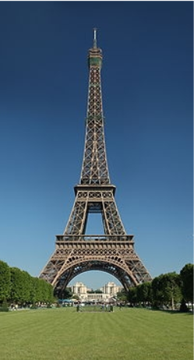 

**Figure 2.18: Original image and image after cropping**

**2.10.3 Image Scaling**

Image scaling is a term used in describing the resizing process of a digital image. Image Scaling is a non-trivial process in which there is a tradeoffs between its efficiency, sharpness and smoothness. But right now, there are a lot of image processing library that capable in handling this issue such as imageScalr and etc which is an optimized incremental scaling algorithm proposed by Chris Campbell.

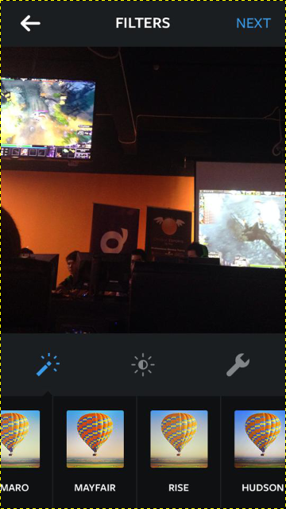 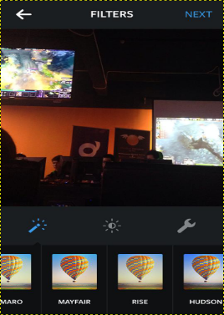

**Figure 2.19: Original image and image after scaling applied**

**2.10.4 Image Gradient**

**3.0 Methodology**